**PLATTSBURGH CITY**

**SCHOOL DISTRICT**

**PBIS – Hornet Culture Counts Handbook**

Be Safe, Responsible and Respectful

Approved: November 2017 (Updated July 2024)

**Table of Contents**

Positive Behavioral Interventions and Supports Defined 3

What is School-wide PBIS? 3

Continuum of School Wide Supports 4

Expectations 7

Teaching Expectations 7

Systems of Acknowledging Appropriate Behavior 8

Systems of Correcting Inappropriate Behavior 9

Major and Minor Behavior Definitions 11

Roles and Responsibilities 14

**Positive Behavioral Interventions and Supports Defined**

Positive Behavioral Interventions and Supports (PBIS) is rooted in the belief that behavior is learned, is related to immediate and social environmental factors, and can be changed. PBIS is based on the idea that students learn appropriate behavior in the same way they learn to read – through instruction, practice, feedback and encouragement. Key features of PBIS include:

1. Administrative leadership

2. Team-based implementation

3. A clear set of defined positive expectations and behaviors

4. Teaching of expected behaviors

5. Recognition of meeting expected behaviors

6. Monitoring and correcting errors in behaviors

7. Using data-based information for decision making, monitoring and evaluating building results

**What is School-wide PBIS?**

School-wide PBIS is a PCSD framework we have in our district and school buildings for creating customized systems that support student outcomes and academic success. Our goal is to recognize the positive expected behaviors regarding being Safe, Responsible and Respectful. PBIS is a systems approach to creating a safer and more productive school.

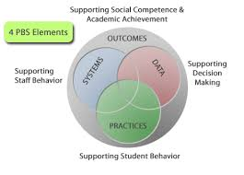

**Continuum of School Wide Supports**

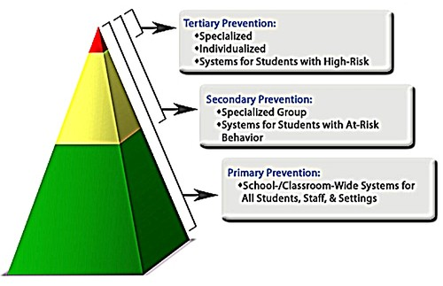

An important aspect of PBIS is the understanding that appropriate behavior and social competence is a skill that requires direct teaching for students. There is no assumption, in PBIS, that students will learn social behavior automatically or pick it up as they go through life.

Primary Prevention

Core Principles

1. **We can effectively teach appropriate behavior to all children.** All PBIS practices are founded on the assumption and belief that all children can exhibit appropriate behavior. As a result, it is our responsibility to identify the contextual setting, events and environmental conditions that enable exhibition of appropriate behavior. We then must determine the means and systems to provide those resources.
2. **Intervene early.** It is best practice to intervene before targeted behaviors occur. If we intervene before problematic behaviors escalate, the interventions are much more manageable. Highly effective universal interventions in the early stages of implementation which are informed by time sensitive and continuous progress monitoring; enjoy strong empirical support for their effectiveness with at risk students.
3. **Use a multi-tier model of service delivery.** PBIS uses an efficient, needs-driven resource deployment system to match behavioral resources with student need. To achieve high rates of student success for all students, instruction in the schools must be differentiated in both nature and intensity. To efficiently differentiate behavioral instruction for all students, PBIS uses tiered models of service delivery.
4. **Use research-validated interventions to the extent available.** The purpose of this requirement is to ensure that students are exposed to curriculum and teaching that has demonstrated effectiveness for the type of student and the setting. Research-based, scientifically validated interventions provide our best opportunity at implementing strategies that will be effective for a large majority of students.
5. **Monitor student progress to inform interventions.** The only method to determine if a student is improving is to monitor the student’s progress. The use of assessments that can be collected frequently and that are sensitive to small changes in student behavior is recommended. Determining the effectiveness (or lack of) an intervention early is important to maximize the impact of that intervention for the student.
6. **Use data to make decisions.** A data-based decision regarding student response to the interventions is central to PBIS practices. Decisions in PBIS practices are based on professional judgement informed directly by student office discipline referral data and performance data. This principle requires that ongoing data collection systems are in place and that resulting data are used to make informed behavioral intervention planning decisions.
7. **Use assessment to screen, diagnose problem behavior and progress monitor.** In PBIS, three types of assessments are used: 1. screening of data comparison per day/per month for total office discipline referrals, 2. Diagnostic determination of data by time of day, problem behavior, and location and 3. Progress monitoring to determine if the behavioral interventions are producing the desired effects.

Secondary Prevention

PBIS is an application of a behaviorally-based systems approach to enhance the capacity of schools, families, and communities to design effective environments that improve the fit or link between research-validated practices and the environments in which teaching and learning occurs. Attention is focused on creating and sustaining primary (school-wide), secondary (targeted group or simple individual plans), and tertiary (individual) systems of support that improve lifestyle results for all children and youth by making problem behavior less effective, efficient, and relevant.

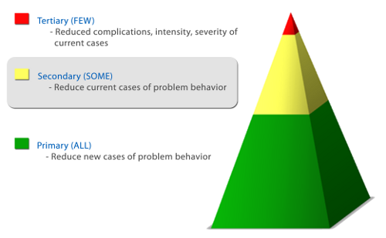

Tertiary Prevention

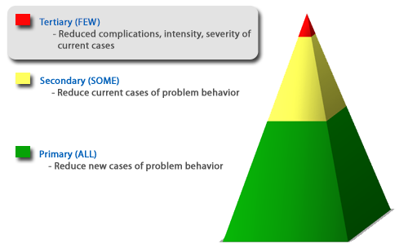

**Expectations**

The primary prevention of positive behavioral interventions and supports consists of rules, routines, and physical arrangements that are developed and taught by school staff to prevent initial occurrences of behavior the school would like to target for change. Students should be able to identify the expectations since they will be posted, taught and referred to throughout the year.

**District Accountability: Implementation Look For**

**Teaching Expectations**

Starting the Year Off Right

During the first week of school, we will focus on teaching the school-wide rules and behavioral expectations to all students across all settings in the school. The PBIS universal team will organize a set of events that will provide students and staff with an informative and positive first week of school in which everyone learns the rules and expectations.

**District Accountability: Documentation of dates and procedures for teaching and**

**reteaching of expectations.**

Why Teach the Rules and Expectations, During the First Week of School?

A major reason to teach a behavioral expectation across settings is so all staff agrees on what is expected. This will improve consistency across staff in enforcing the school rules. We also cannot assume that students know the expectations and routines.

Booster Sessions: Re-Teaching Rules and Expectations

We must remember that we cannot simply teach the rules and expectations once. It is important to hold booster sessions to review expectations. Booster sessions are especially helpful after returning from a long break, during times in the year when you anticipate having more troubles, or in areas that continue to be problematic. Booster sessions may include re-teaching expectations, increasing the number of acknowledgement events, etc.

**Systems of Acknowledging Appropriate Behavior**

Why Do We Want to Recognize Expected Behavior?

It is not enough just to teach expected behavior, we also need to regularly recognize and reward students for engaging in appropriate behavior. Research has shown that recognizing students for engaging in expected behavior is even more important than catching students breaking the rules. Research on effective teaching has found that staff should engage in a rate of 4 positive interactions with students to every 1 negative interaction.

When adults acknowledge positive behavior they should:

* Be positive
* Be specific, clear
* Acknowledge immediately
* Initiate the action

Acknowledgement should be free and frequent and can include verbal praise, a smile, stickers, a high five, thumbs up, note home, etc.

**District Accountability: documentation of non-criterion celebration date and activity,**

**Implementation Look For**

ebration

**Systems of Correcting Inappropriate Behavior**

Consistent and fair discipline procedures are crucial to a successful consequence system in all schools. It is important that we are respectful of students in our disciplinary responses. Consequences should focus on:

* Re-teaching/Strategies for correcting behavior
* Reflection
* Logical consequences

In order to maximize student instructional time staff are encouraged to deal with problem behavior in their classroom as much as possible. This requires that staff develop a clear discipline plan which teaches expectations, provides incentives for positive behavior and identifies clear responses to problem behavior within the classroom.

Adult behavior when providing correction needs to be:

* Calm
* Consistent
* Brief
* Immediate
* Respectful

**Correction Procedure-**

**Steps to Address Behavior (need to be used in the order given)**

1. Non-verbal cue (look/proximity)
2. Restate expectations / Check for understanding / Reinforce (verbally) / Move on
3. Reflection time within the classroom (2 minutes). Teacher checks in with student to return to instruction. Reset an additional 2 minutes if needed.
4. Reteach outside of instruction (time may vary for individual need). The goal is to return the student to instruction as soon as possible after the behavioral skill set has been practiced. Reteaching occurs by Classroom Teacher (adult in charge of setting).

**Classroom Discipline Referral (CDR) Definitions**

Please see the district-wide Office Discipline Referral, Classroom Discipline Referral, Reteaching Form, and Student Behavior Management Process on pages 13-18.

Student Signature: ________________________________________________________________________________

Parent/Guardian Signature (Optional): _________________________________________________________________

Teacher/Staff Signature: ____________________________________________________________________________

**Roles and Responsibilities**

Schools Must:

1. Post the behavioral expectations and behavior matrix throughout the school for all students and staff to see daily.
2. Teach the behavioral rules and expectations within the first week of school for all settings within the building (classroom, hallway, bathroom, cafeteria, playground/athletic area, etc.)
3. Review behavioral data monthly.
4. Establish universal reinforcement systems (school-wide and classroom)
5. Establish a behavior management plan within each classroom
6. Provide booster sessions/opportunities to re-teach the rules and expectations throughout the year based on the data that is being reviewed by the universal team.

PBIS Coach Responsibilities:

1. Work with District Coach
2. Attend monthly PBIS Leadership Team meetings
3. Become a PBIS expert
4. Facilitate school-level PBIS activities
5. Ensure that the universal team meets
6. Update PBIS portion of school webpage
7. Summarize data from previous month for universal team
8. Make sure school-wide expectations are posted
9. Monitor universal reward procedures
10. Help plan kickoff event for start of school year
11. Seek input from staff when needed
12. Attend District/Regional coaching training

Classroom Teacher Responsibilities:

1. Teach, model, and practice each of the school-wide behavioral expectations
2. Display and use the classroom expectations based upon their school-wide expectations
3. Use the Universal Team and Child Study Team when working with students who do not meet school-wide and classroom expectations
4. Develop and/or use PBIS established strategies for recognizing students who meet or exceed school-wide and classroom expectations using informal and formal recognition programs

Staff Responsibilities (adults with any form of supervisory authority):

1. Circulate among students and observe students to see that they are meeting school-wide expectations in all non-classroom settings of the school (active supervision)
2. Talk with students and provide feedback based on school-wide expectations
3. Use the Universal Team and Child Study Team when working with students who do not meet school-wide and classroom expectations
4. Develop and/or use PBIS established strategies for recognizing students who meet or exceed school-wide and classroom expectations using informal and formal recognition programs

Universal Team Responsibilities:

1. Team should consist of representatives from the school community – 1to 2 of these individuals should possess behavior/classroom management competence
2. Administrator should be an active member
3. Schedule for presenting to whole staff at least monthly (faculty meetings)
4. Schedule for team meetings at least monthly
5. Integration with other behavior related initiatives and programs
6. Appropriate priority relative to school and district goals
7. Rules and agreements established regarding voting, confidentiality and privacy, conflict/problem solving, record-keeping, etc.
8. Schedule for annual self-assessments
   1. EBS Self-Assessment Survey
   2. Review Office Discipline Referrals
   3. Benchmarks of Quality
   4. School-wide Evaluation Tool